**ASSIGNMENT 5**

**Q1. Write a Python program to Count all letters, digits, and special symbols from the given string**

**Input = “P@#yn26at^&i5ve”**

**Solution:**

text = input("Enter some text: ")

length = len(text)

letters = 0

digits = 0

symbols = 0

for i in range(length):

    if text[i].isalpha():

        letters+=1

    elif text[i].isdigit():

        digits+=1

    else:

        symbols+=1

print(f"The given input string {text} contains \n{letters} letters, \n{digits} digits and \n{symbols} symbols.")

**Output:**

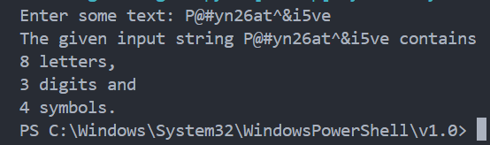

**Q2. Write a Python program to remove duplicate characters of a given string.**

**Input = “String and String Function”**

**Solution:**

text = input("Enter some text: ")

text = text.lower()

word=""

for i in text:

    if i not in word:

        word+=i

print(word)

Output:

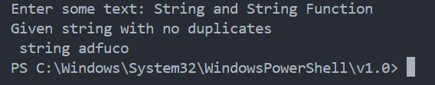

**Q3. Write a Python program to count Uppercase, Lowercase, special character and numeric values in a given string**

**# Input = “Hell0 W0rld ! 123 * # welcome to pYtHoN”**

**Solution:**

textInput = input("Enter some text: ")

length = len(textInput)

uppercase = 0

lowercase = 0

special = 0

numeric = 0

for i in range(length):

    if textInput[i].isupper():

        uppercase+=1

    elif textInput[i].islower():

        lowercase+=1

    elif textInput[i].isdigit():

        numeric+=1

    else:

        special+=1

print(f"The given input has \n{uppercase} Uppercase characters, \n{lowercase} Lowercase characters, \n{numeric} Numeric characters and \n{special} special characters")

**Output:**

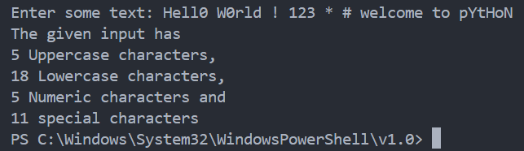

**Q4. Write a Python Count vowels in a string.**

**Input= “Welcome to Python Assignment”**

**Solution:**

textInput = input("Enter some text: ")

vowels=0

consonants=0

for i in range(0, len(textInput)):

    if textInput[i].lower() in "aeiou":

        vowels+=1

    else:

        consonants+=1

print("Vowels", vowels)

**Output:**

